**Article Authors:** David Akin

**Article Title:** DYMAFLEX DYNAMIC MANIPULATION FLIGHT EXPERIMENT

**Purpose of the study: “**Improve understanding of the dynamics of the coupling of modern robotic arms and their host spacecraft and to demonstrate and validate proposed controllers in the space environment.”

**Research Questions:** Exercise in free-flying manipulation and characterize threat of near-earth objects

**Current Knowledge on Topic/Introduction:**

Equations of motion: 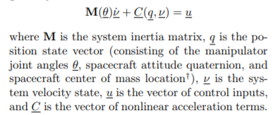

Lots of other mathematics for describing a coupled dynamical system we can use for 3D printing (maybe even a triply combined dynamical system?)

Control strategies:

Transpose Jacobian

Modified Transpose Jacobian

Filtered Modified Transpose Jacobian

Tested controllers and commanded value tables in paper

**Results/Future Work:**

Introduction of measurement noise reversed findings (TJ worse than MTJ, worse than FMTJ). Suggest real on-orbit experimentation as opposed to simulated.

**Relation to Project:**We will need control strategies for the robotic arm to print effectively if we choose satellite-servicing path

**Sources (Is there more info in *its* sources?):**

**Additional Notes:**

Explicit dynamics of space free-flyers with multiple manipulators via SPACEMAPLE

[**https://pdfs.semanticscholar.org/f09b/354db8bd0cd5a1a1728ab3bf8a6192ed244e.pdf**](https://pdfs.semanticscholar.org/f09b/354db8bd0cd5a1a1728ab3bf8a6192ed244e.pdf)Second half includes the design of the DYMAFLEX instead of the controls theory